EeE
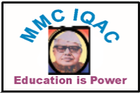
PDEA’S
Mamasaheb Mohol College,
(Arts commerce & science)
Paud Road Pune -38

Event Calendar 2023-24
Name of Committee: Hindi
Sr. No | Name of Activity | Tentative date
1 | Shuddhalekhan Workshop | 12/08/2022
2 | Nibandh Spardha | 13/09/2023
3 | Hindi Day Celebration | 14/09/2023
4 | Vachan Prerana Divas | 15 /10/2023
5 | Doha Spardha | 15/10/2023
6 | Slow Learning Course | 20/11/2023
7 | Mr.Sharad Pawar Birthday celebration | 12/12/2023
8 | Kavya Vachan Spardha | 27/12/2023
9 | Surynamskar Din | 15/01/2024
10 | Mahila Divas | 08/03/2024

Head of the Hindi Department

Prof.Hingmire S.P.

